BECOMING INFLUENTIAL

a workbook for architects
and other people

tim@culvahouse.net | 415.309.2085

Mapping My Existing Network

What fellow architects do I keep up with?

name | firm | role | location

What consultants do I keep up with?

name | firm | role | location

What builders do I keep up with?

name | firm | role | location

What clients do I keep up with?

name | firm | role | location
Who do I keep up with from college or graduate school?

name | field | role | location

Who do I keep up with from my hometown?

name | field | role | location

Who do I keep up with from my immediate and extended family?

name | field | role | location

Who else do I keep up with?

name | field | role | location
Where has my work been published?

journal | author | editor | date

Where has my writing been published?

journal | editor-in-chief | editor I worked with | date

What awards has my work received?

award | organization | date | jurors

What professional organizations do I belong to?

organization | executive director | program director | location

What non-professional organizations do I belong to?

organization | executive director | program director | location
Map ‘Em

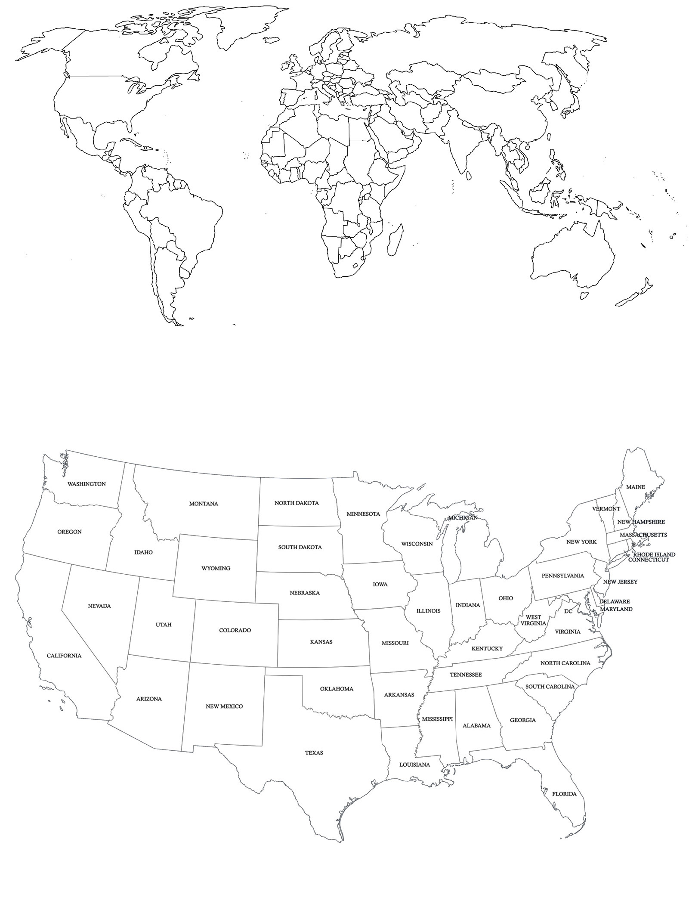
Articulating My Expertise

What professional skills am I particularly good at?
[design, project management, material innovation, curtain wall detailing . . .]

In what professional areas am I particularly knowledgeable?
[may correspond to skills from the list above, but don’t have to]

What non-professional skills am I particularly good at?
[cooking, tennis, poker . . .]

In what non-professional areas am I particularly knowledgeable?
[foreign languages, ornithology, British detective fiction . . .]

Mapping an Expanded Network

From the previous page, choose one of the professional areas in which you are particularly knowledgeable:

What are significant current issues in this area of knowledge?

What is your distinctive position on one of these issues?

Who are recognized experts in this area?

expert | location | institution | noted works

Who writes about this area of knowledge?

author | location | publication(s)

What organizations support and advance this area of knowledge?

organization | executive director | program director | location

What colleges and universities are recognized for this area of knowledge?

college or university | unit dean or chair | relevant faculty | location

What conferences support and advance this area of knowledge?

conference | organization | conference organizer | presentation formats

What publications support and advance this area of knowledge?

publication | editor | frequency | location

What awards recognize excellence in this area of knowledge?

award | organization | organization contact | location
Making a Plan to Extend My Network

What communication channels am I good at?

Face-to-face, one-on-one conversation . . .
. . . over a meal.
. . . over coffee.
. . . over drinks.
. . . on the golf course.
. . . while playing other sports:
. . . while playing cards.
. . . while playing chess, checkers, dominoes . . . .

By telephone.

By email.

By fax.

In discussion groups.

On social media.
Twitter
Facebook
LinkedIn
Pinterest
Other:

Handwritten notes, sent through the post.

Construction documents.

Captioned drawings.

Public speaking: solo.

Public speaking: panel discussions.

Video, as talking head, writer, director, producer.

Participation on committees, boards.

Other:

What communication channels do I want to be good at?

Face-to-face, one-on-one conversation . . .
. . . over a meal.
. . . over coffee.
. . . over drinks.
. . . on the golf course.
. . . while playing other sports:
. . . while playing cards.
. . . while playing chess, checkers, dominoes . . . .

By telephone.

By email.

By fax.

In discussion groups.

On social media.
Twitter
Facebook
LinkedIn
Pinterest
Other:

Handwritten notes, sent through the post.

Construction documents.

Captioned drawings.

Public speaking: solo.

Public speaking: panel discussions.

Video, as talking head, writer, director, producer.

Participation on committees, boards.

Other:

Look for ways to get better at the ones you’ve identified.
Mix ‘n’ Match 1: Collectively, Purpose Foremost
With a group of several colleagues come up with a cool topic for a panel discussion. Each participant suggests a panelist for a discussion on that topic.
Together, the participants imagine:
—how to invite the panelists;
—where to hold the panel discussion; and
—how to promote it.

Cool Topic

 | Why they’re relevant | How to Invite
Panelist 1

Panelist 2

Panelist 3

Panelist 4

Panelist 5

Venue
Promotion

Mix ‘n’ Match 2: Collectively, People Foremost
Without discussing a topic, each participant proposes an interesting person.
Based on the individuals proposed, participants collectively come up with a cool topic for a panel discussion among them.
Based on that topic, participants together imagine:
—how to invite the panelists;
—where to hold the panel discussion; and
—how to promote it.

 | Why they’re Interesting | How to Invite
Panelist 1

Panelist 2

Panelist 3

Panelist 4

Panelist 5

Cool Topic

Venue
Promotion

Mix ‘n’ Match: On Your Own

Person from hometown | + |  | Consultant | = |  | Cool Idea #1
Person from college | + |  | Client | = |  | Cool Idea #2
Person from family | + |  | Architect | = |  | Cool Idea #3
Person of my choice | + |  | Person of my choice | = |  | Cool Idea #4
Person of my choice | + |  | Person of my choice | = |  | Cool Idea #5

Things I can do to share what I know with an expanded network:

1.
2.
3.
4.

The beginning of a plan to do one of these things:

 | person | organization
Who do I know who can help me?
Who could help me if I knew them? | a.
 | b.
 | c.
Who could introduce me to “a”?
Who could introduce me to “b”?
Who could introduce me to “c”?
Where do my interests intersect with the interests of “a”?
Where do my interests intersect with the interests of “b”?
Where do my interests intersect with the interests of “c”?
How can I introduce myself to “a”? What would interest him or her?
How can I introduce myself to “b”? What would interest him or her?
How can I introduce myself to “c”? What would interest him or her?

Working a Convention: how I will spend my time:

Sessions I can attend that correspond with my expertise
Speakers I can introduce myself to who correspond with my expertise
Vendors that can provide information to advance my expertise
Editors interested in my expertise, to whom I can introduce myself
Other conference attendees I will spend time with to build connections
People outside the Convention I will spend time with to build connections
Other ideas

Things I can do to share what I know within my office:

1.
2.
3.
4.
5.

